EE 281 Logic Design Lab

Lab 1

Introduction to EE 281 Lab

## Name: Ajin Sunny

## Lab Partner: Derek King

## Date of Experiment: January 26th 2015

## Date of Completion of Report: January 31, 2015

Introduction

In this Lab we will familiarize ourselves with TTL NAND Gates and Build a General Logic circuit. With the use of switches and LED’s on the proto boards for inputs and outputs along with the waveforms software on a computer we will be able to build and test the circuit. We will implement two equations using only two input NAND gates Secondly we will build an infrared heating oven containing three heating elements and one fan. We are assigned to design a simple combinational logic using only Quad 2 input NAND gates and one inverter chip. After designing we will have to test the circuit and calculate the power for TTL portion of the circuit using the multi meter provided in the explorer board.

Experiment Description

**Part 1**

F(W,X,Y,Z) = Σ m(0,2,4)

|  |  |  |  |  |  |
| --- | --- | --- | --- | --- | --- |
|  | WX |  |  |  |  |
| YZ |  | 00 | 01 | 11 | 10 |
|  | 00 | 1 | 1 | 0 | 0 |
|  | 01 | 0 | 0 | 0 | 0 |
|  | 11 | 1 | 0 | 0 | 0 |
|  | 10 | 0 | 0 | 0 | 0 |

Figure 1

As you see the equation for the logic for given above can be drawn in K-Maps as shown in Fig 1. Where the 1s are grouped together since they are sum of products.

By looking at the K-Map we obtain the following min terms for the final equation

F = $\overline{W} \overline{Y} \overline{Z}$ + $\overline{W}\overline{X} YZ$

By using the above logic we decide to draw a combinational logic as shown in Figure 2. This combinational logic outputs the final F which we require.

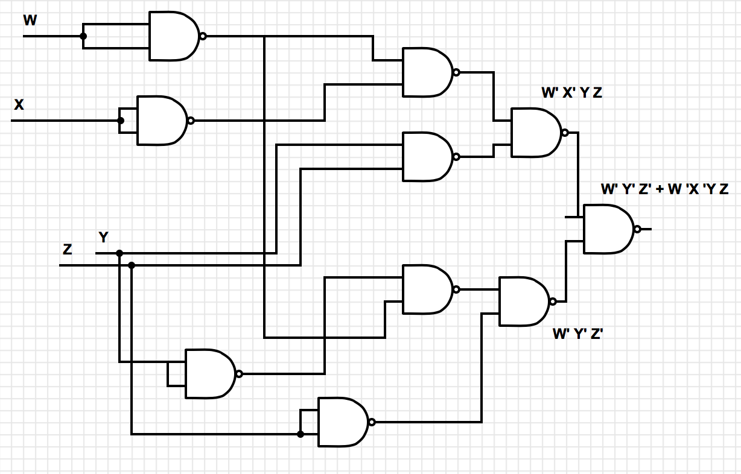

Figure 2

**Part 2**

F(X,Y,Z) = Σ m(0,2,4,7)

Similarly as seen above we will draw the K-Maps for the equation shown below in Fig 3. The finalized SOP products circuit will be as shown below highlighted.

Figure 3

|  |  |  |  |  |
| --- | --- | --- | --- | --- |
| XY  Z | 00 | 01 | 11 | 10 |
| 0 | 1 | 1 | 0 | 1 |
| 1 | 0 | 0 | 1 | 0 |

Now the finalized equation for the Logic give above is as follows:

F = $\overline{X} \overline{Z}$ + $\overline{Y} \overline{Z}+XYZ$

By using the information from the K-Map and the final output equation of the Logic for the equation given in Part 2 of the Lab. We finally designed a combinational logic for the circuit as shown in Figure 4.

**Part 3**

**Infrared Heating Oven**

In this part of the experiment we are given the logic of how the Heating Oven is suppose to perform. **The oven contains 3 heating elements H1 , H2 , H3 and one fan F1. The given condition explains that if any adjacent heating elements fail or if the fan fails then the circuit will output a one**. We used the switches and LED’s on the protoboard in the lab for inputs and outputs to test the circuit.

We designed a combinational logic circuit using only NAND gates (2 input – 7400) and one inverter chip (7404) that outputs one when the above condition explained is met.

1. H1 =0 and H2 =0

2. H2 =0 and H3 =0

3. H1 =0 and H3 =0

4. F1 =0

Figure 4

**Truth Table**

|  |  |  |  |  |
| --- | --- | --- | --- | --- |
| F1H1  H2H3 | 00 | 01 | 11 | 10 |
| 00 | 1 | 1 | 1 | 1 |
| 01 | 1 | 1 | 0 | 1 |
| 11 | 1 | 1 | 0 | 0 |
| 10 | 1 | 1 | 0 | 1 |

|  |  |  |  |  |
| --- | --- | --- | --- | --- |
| F1 | H1 | H2 | H3 | f |
| 0 | 0 | 0 | 0 | 1 |
| 0 | 0 | 0 | 1 | 1 |
| 0 | 0 | 1 | 0 | 1 |
| 0 | 0 | 1 | 1 | 1 |
| 0 | 1 | 0 | 0 | 1 |
| 0 | 1 | 0 | 1 | 1 |
| 0 | 1 | 1 | 0 | 1 |
| 0 | 1 | 1 | 1 | 1 |
| 1 | 0 | 0 | 0 | 1 |
| 1 | 0 | 0 | 1 | 1 |
| 1 | 0 | 1 | 0 | 1 |
| 1 | 0 | 1 | 1 | 0 |
| 1 | 1 | 0 | 0 | 1 |
| 1 | 1 | 0 | 1 | 0 |
| 1 | 1 | 1 | 0 | 0 |
| 1 | 1 | 1 | 1 | 0 |

Therefore the logic for the given condition of the heating elements can be derived from the truth table given above and then use the information from the truth table tp draw the K Map. We can reduce the Sum of Products equation from the K Map by grouping the octets, quads and pairs in the the Kmap

After doing the required grouping we finally get the equation as given below:

$$F=\left(\overline{F1}+\overline{H1} \overline{H3}\right)+(\overline{H2 } \overline{H3}+\overline{H1} \overline{H2})$$

The Logic Design for the above equation is given below:

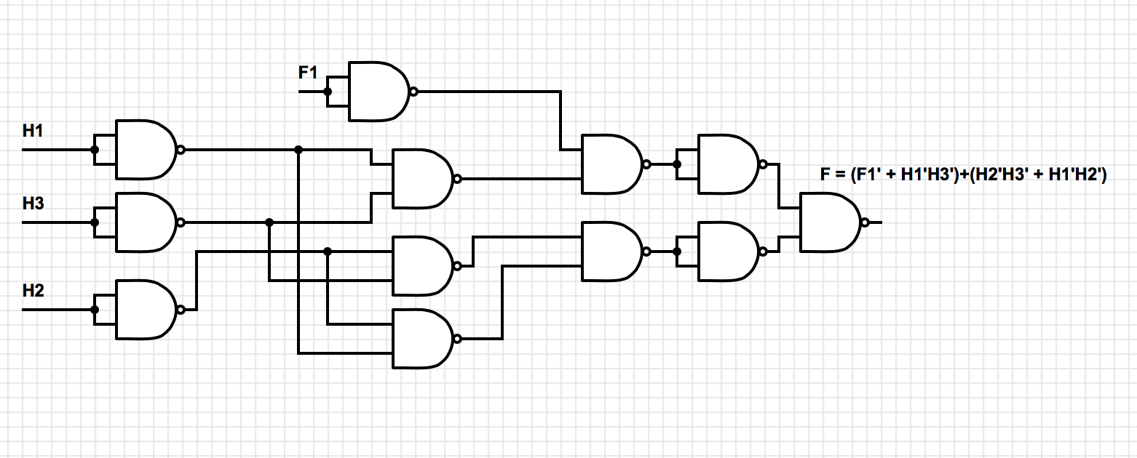

Now after completing the design of the Logic circuit we build the logic circuit on the protoboard and used the waveforms software to test the logic of the circuit . The switches and LED’s on the waveforms proved the validity of circuit and was approved by the Instructor in charge.

Finally the power comsumption of the TTL portion of the circuit can be calculated by using the multimeter function of the explorer board. From the multimeter of the explorer board it was indicated that

V = 3.35 Volts

And current

I = 10mA

Therefore Power = V * I

= 3.35V * 10mA

= 0.0335 W

Note: The current displayed from the waveforms is suppose to be a slightly more minimal amount. The reason for the rise in current is due the excessive resistance present in the wires. This will increase the overall power of the TTL portion of the circuit.

Results:

Part 1:

In the first part of the experiment the circuit asked us to build the logic design for f(W,X,Y,Z) = Σ m (0,2,4) . We built this logic by using Quad 2 input NAND Gates and the results worked just as expected. Our final combinational logic turned out to be what as expected.

Part 2:

Similarly in the second part of the experiment we built a logic design for the circuit used to implement the equation f(X,Y,Z) = Σ m (0,2,4,7). We also built this logic by using one Quad 2 input NAND gates and one Hex inverter chip. The output for the circuit worked just as expected.

Part 3:

In the third part of the experiment, we used the logic given for the heating oven where the oven combinational logic output turns 1 when either the fan fails or any of the adjacent heating elements fails. The result derived from the truth table and the KMap led us to the equation f(H1,H2,H3,F1) = ($\overline{F1}+\overline{H1} \overline{H3})+(\overline{H2 } \overline{H3}+\overline{H1} \overline{H2}$). The outputs for the combinational logic worked just as expected and we also verified the logic by using the proto board and waveforms on the computer to toggle between switches to check the LED’s turn on and off in the correct fashion. Calculation of power was also done to produce a power of 0.035W. Although it is considered to be slightly inaccurate value this is due a slight increase in the current in the circuit caused due excessive wires present in the circuit.

Conclusion:

In conclusion to this experiment, we learned and gained experience on using lab equipment’s as well as components such as Quad 2 input NAND Gates and Hex inverters. We also gained experience on how to design and implement the Boolean Logic on a proto board and test it with relevant test cases to give the required result. Calculation of power was also done by using the multi meter values present in the software, which gives us the flow of the current and the voltage in the TTL portion of the circuit.